EXP No : 4b

Date: 20 / 03 / 2025

TITLE: Conduct task analysis for an app and

document user flows. Create corresponding wireframes using dia

# AIM:

The aim is to perform task analysis for an app, such as online shopping, document user flows, and create corresponding wireframes using Dia.

# PROCEDURE:

**1. Install Dia:**

Download Dia from <http://dia-installer.de/>

Install and launch the application.

**2. Create a New Diagram:**

Go to **File → New Diagram**

Select **Flowchart** as the diagram type.

**3. Add Shapes:**

Use rectangles, ellipses, and diamonds to represent different stages:

**Start** → Oval

**Login/Register** → Rectangle

**Search Tickets** → Rectangle

**Select Date, Time, Preferences** → Rectangle

**Check Availability** → Rectangle

**Decision (Tickets Available?)** → Diamond

**Payment Process** → Rectangle

**Generate Confirmation** → Rectangle

**Send Ticket via Email/SMS** → Rectangle

**End** → Oval

**4. Connect Shapes:**

Use lines to define user flow:

**Start → Login/Register**

**Login/Register → Search Tickets**

**Search Tickets → Select Date, Time, Preferences**

**Select Date, Time, Preferences → Check Availability**

**Check Availability → (Decision: Tickets Available?)**

**Yes → Proceed to Payment**

**No → Show Error & End**

**Proceed to Payment → Generate Confirmation → Send Ticket via Email/SMS → End**

**5. Label Shapes:**

Double-click each shape to add labels like **Login**, **Search**, **Payment**, **Confirm Ticket**, etc.

**6. Save the Diagram:**

Go to **File → Save As**

Name it **"Ticket Booking System Flowchart"**.

# OUTPUT:

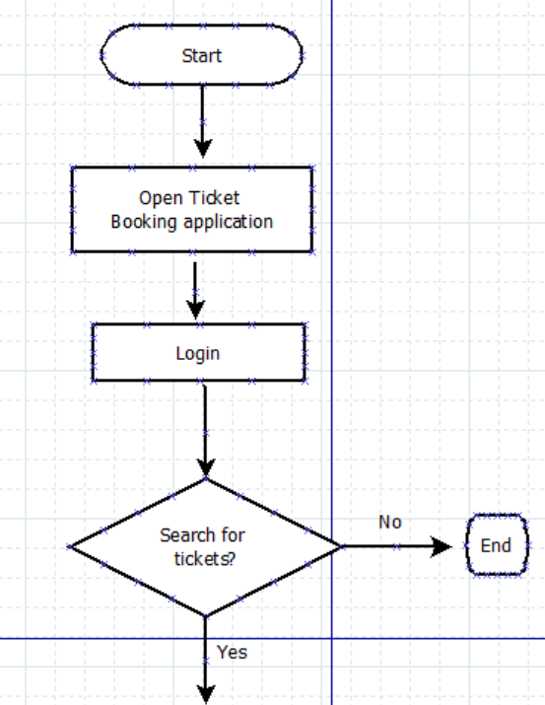

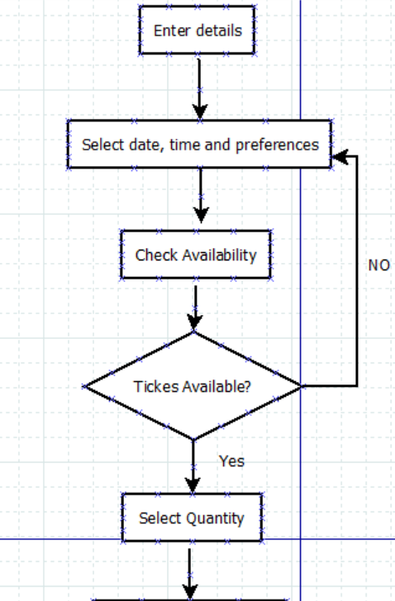

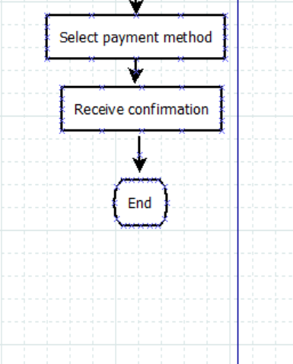

# RESULT:

A wireframe is created for ticket booking system in Dia by adding and connecting shapes for login, search, seat selection, payment, and ticket generation.